**Chapter 8 Exercises**

8.1 Add a Diagnostic Overview to the project 2

8.1.1 Add a Diagnostic Overview to the Project 3

1) Add a Diagnostic Overview to the Project 3

8.2 Create a PLC Program Alarm 5

8.2.1 Add necessary PLC code to create a program alarm 6

1) Add the code required for a Program Alarm 6

# 

# 8.1 Add a Diagnostic Overview to the project

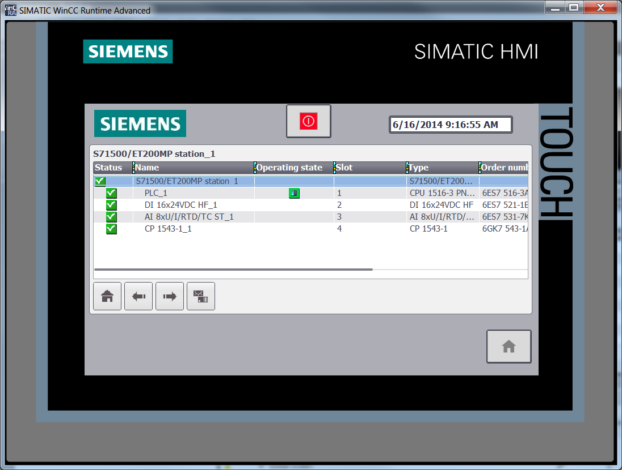

**Description**

The diagnostic overview is a “Control” object that can be added to the comfort panel and advanced PC runtime application and provides the overall diagnostic information of attached PLCs and the details information about hardware failures. The object mimics the diagnostic information presented on the front panel display of the S7-1500.

In this exercise, the Diagnostic Overview will be added to provide the operator with diagnostic status and fault information.

**Objectives**

Upon completion of this exercise, the student shall be able to:

* Add a Diagnostic Overview to the Project.

**Prerequisites**

The following prerequisites must be completed before this exercise is started:

* Chapter 7 Exercises have been completed, OR the Chapter 8 Seed Project archive has been retrieved and opened for editing.

### 8.1.1 Add a Diagnostic Overview to the Project

|  |
| --- |
| 1. Add a Diagnostic Overview to the Project 2. Open the HMI screen “Enhanced Objects” for editing. 3. Remove the screen label added earlier. 4. From the Task cards, access the “Toolbox” 5. Under “Controls”, add the Diagnostic Overview to the screen using drag and drop. 6. Resize the object as necessary.      1. Browse the Properties of the display to see what items are configurable. Note that the default settings work for most applications. 2. Add a Diagnostic Indicator to the overview area to navigate to the “Enhanced objects screen when pressed. From “Global libraries” 🡺”Buttons and Switches”🡺”Master Copies”🡺”Diagnostics Buttons”🡺”Comfort Panels and RT Advanced” drag the “DiagnosticsIndicator” onto the overview area.      1. Configure the DiagnosticsIndicator as shown below. Note that an existing Event must be removed prior to adding the one shown below.      1. Download your changes to the HMI. Access the “Enhanced Objects” screen and test the new display by removing a module from the ET200SP station.   *This completes Exercise 8.1.* |

# 8.2 Create a PLC Program Alarm

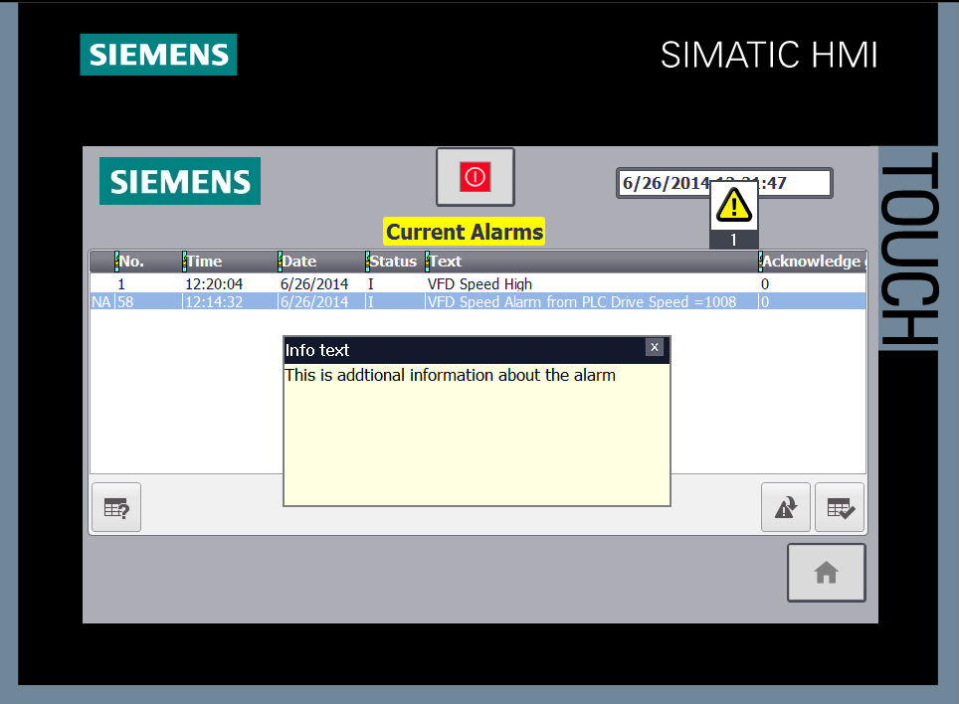

**Description**

While alarms can be configured directly in the HMI application, keeping alarms synchronized across multiple HMIs can become difficult as the alarms grow in number. Generating alarms from the attached PLC and leveraging the message number procedure can help in keeping all attached HMI alarms synchronized.

In this exercise, the PLC instruction “Program_Alarm” will be used to generate an alarm similar to the VFD Speed High alarm configured earlier. It will require adding a function block to the PLC program, then calling the “Program_Alarm” instruction and parameterizing it.

**Reference:** Study Guide Chapter 9.

**Objectives**

Upon completion of this exercise, the student shall be able to:

* Add and configure a “Program_Alarm” instruction.

**Prerequisites**

The following prerequisites must be completed before this exercise is started:

* Exercise 8.1 has been completed.

### 8.2.1 Add necessary PLC code to create a program alarm

|  |
| --- |
| 1. Add the code required for a Program Alarm 2. From the Project tree, double-click on “Add new block” for the 1500, PLC_1. 3. Select Function Block. Assign the name “PLC Alarms”. Accept the default automatic number. 4. Select LAD as the programming language. Leave “Add new and open” checked, and click OK to add the block.      1. In the new FB interface, declare the following input variables:      1. From the task card, select “Instructions”. Under the “Extended instructions”, expand the branch labeled “Alarming”. 2. Add a “Program_Alarm” instruction to Network 1. From the Instance dialog that appears, assign the instance name of “VFD Speed Alarm from PLC” and click OK.      1. Add the following code to examine the value of the analog trigger tag and compare it to the setpoint. This will be our alarm trigger. Note the comparison instruction is for the data type INT.      1. Access the “Program_Alarm” properties. Under the “Alarm” tab, select “Basic settings”. 2. Assign the Alarm class “No Acknowledgement”   **NOTE** We want to display the name of the alarm and the value when it triggers in the alarm message. This requires adding associated values to the alarm text field.   1. In the “Alarm text” field of the Basic settings, right mouse click to bring up the context menu. From the list that appears, select “Insert keyword…”      1. From the dialog that appears, select “Alarm name”, then click the green check mark.      1. Immediately after the last “carat” of the keyword expression, enter the text “Current Speed =”. Your text should now look like the figure below.      1. Immediately after the entered text, right mouse click again. From the menu, select “Insert dynamic parameter (tag)”. In the field, select the value “#Trigger_Tag”. Under “Format”, select “Decimal with sign”.      1. Your completed alarm properties should look like the figure below:      1. Access the “Additional alarm texts”. In the “Info text” field, enter “This is the additional information about the alarm”.      1. Open Main [OB1] for editing. Add a call to the “PLC Alarms” block in the next available network. Accept the default data block name and click “OK” to add the block. 2. Parameterize the call as shown below.      1. Download your changes to the PLC. 2. Add an Alarm Display to the Comfort Panel HMI 3. Open the HMI Alarms screen for editing. 4. In the Inspector Window, access the Toolbox. 5. Under the “Control” group, add an Alarm view to the screen using drag and drop. Resize it as necessary. 6. Access the Alarm view properties. Under General, select the alarm classes Acknowledgement and No acknowledgement. Also select Current alarm states of both Pending and Unacknowledged alarms.      1. Download the changes to you Comfort Panel. 2. Test the new alarm by navigating to the Drive Control Screen and making the drive exceed the trigger setpoint by entering a speed setpoint greater than 1000. 3. Access the S7-1500 Display. Observe the alarm is also reported in full on the Display under the Diagnostics menu.   *This completes the Chapter 8 Exercises.* |